**Hibernate 101**

**Object/relational Persistence**

1. In a Database we have 2 main property that must be followed
   1. **Entity Integrity**: every table has a primary key and NULL values are not allowed for primary key.
   2. **Referential Integrity**: A foreign key points at a value that is the primary key of another table. NULL value is valid in foreign key column but if a value exits in a foreign column, then it must refer to a valid reference.

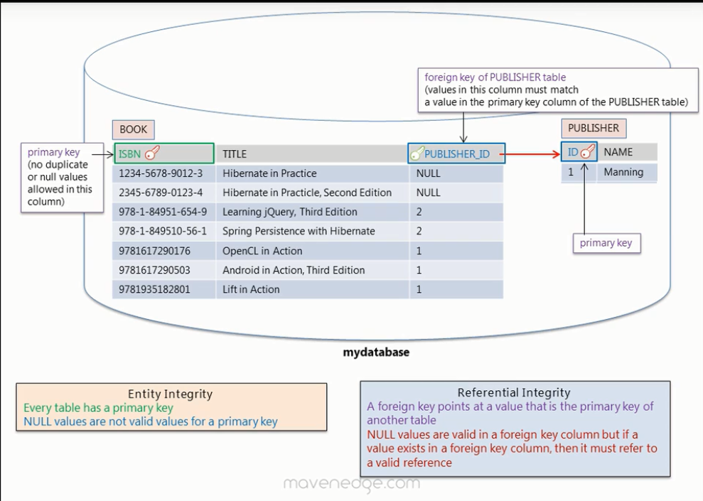

1. Object Model: Graphs of object

Relational Model: Table like format

1. Object Model is more granular, supports inheritance, and Identity is based on object equality while in relational model the identity equality is via primary key.

**Hibernate and JPA Annotations**

1. Example of Object Relational mappings:

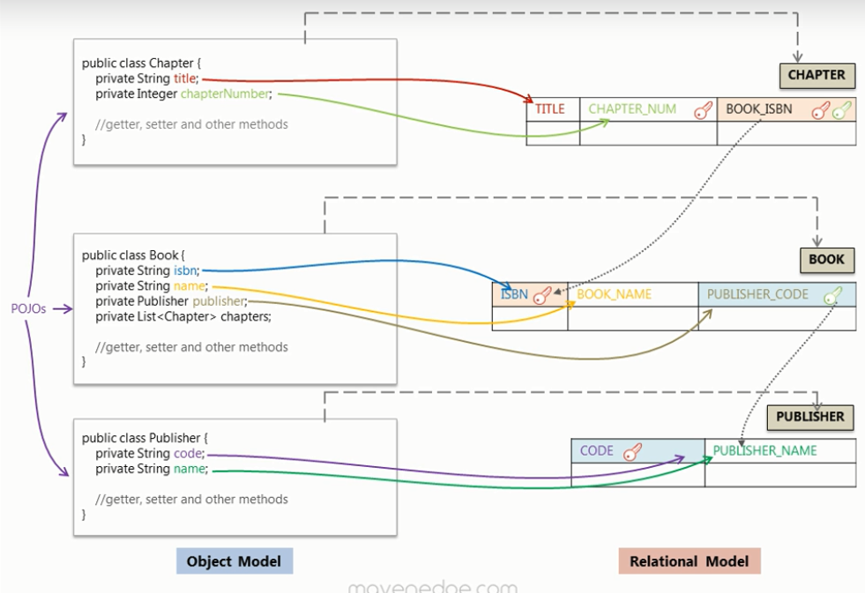

1. We make 1 session factory for 1 data source as it is resource intensive.
2. Make use for log4j for logging purpose:

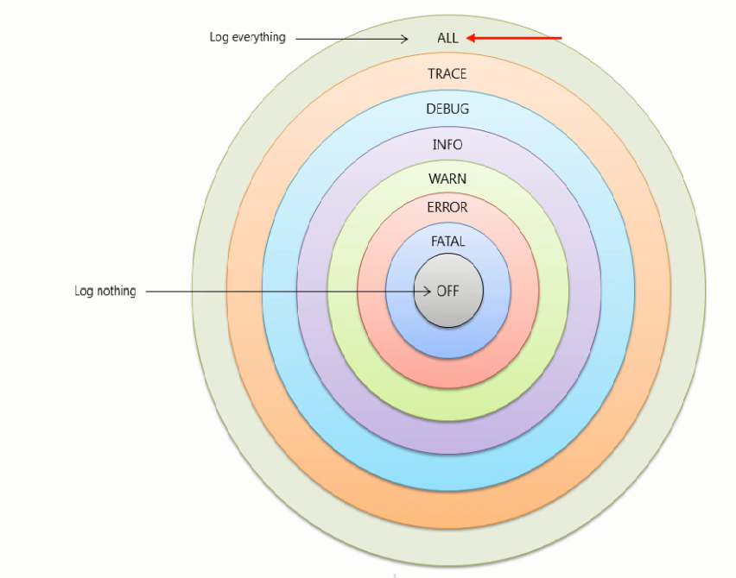

1. Transactions in Hibernate? These are a group of operations that run as a single unit of work. When ever we modify the state of an object inside a transaction(Update operation) , then it performs **Dirty Checking** and updates that object in data base. Only when the transactions is committed then only we see the entry/update or deletion from database.
2. We must have a default constructor so that hibernate can instantiate objects using reflection.

**Mapping Concepts**

1. Aggregation indicates a relationship between a whole and its parts unlike Composition which is a strong form of aggregation and when whole is destroyed its parts also destroy with it.
2. Observe this: right side 2 class approach is better design. Why we gave ‘id’ to user class? Cause we cared about that only to uniquely identify.

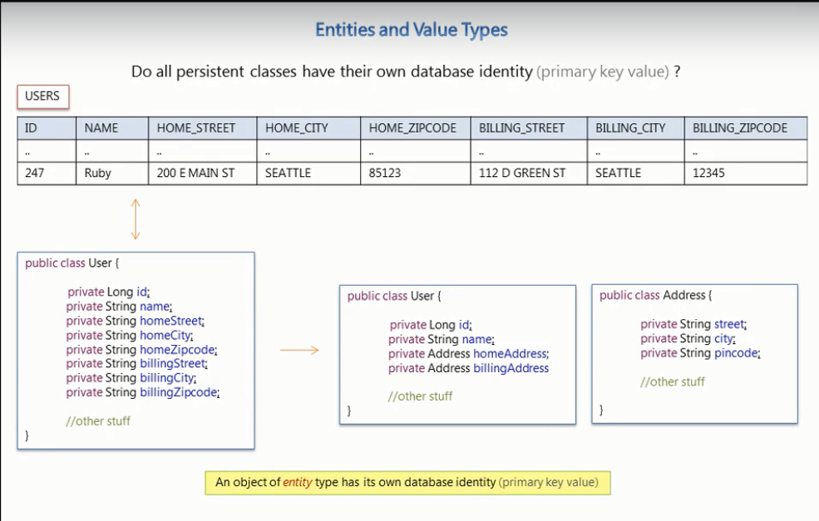

1. A object of **entity type** has its own datatype identity (primary key value).
2. A **value type** objects are identified through the owning entity.
3. **Note:** During the establishment of a bi-directional relationship we make use of the **mappedBy** attribute.

In the below example this attribute tells hibernate to load the collection of students using the foreign key column already mapped by the guide attribute.

1. In a Bi-directional relationship one of the sides is the owner of the relation and is responsible for the association(guide_id) column update. **Many** side in a such cases are usually the owners.

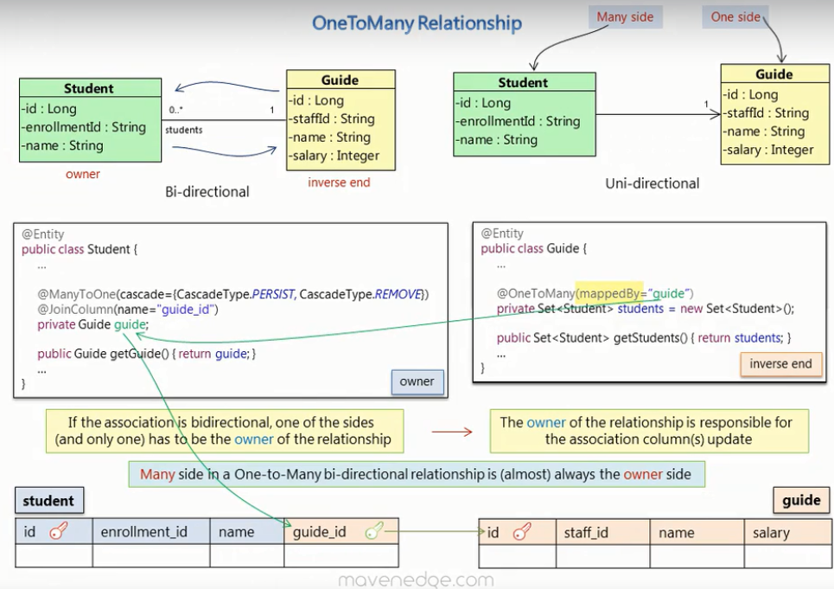

1. **NOTE:** If we update the inverse end then changes are not updated for the owner table (association column don’t get updated). While on updating the owner end everything gets updated.
2. **Owner** is the entity that is persisted to the table that has the foreign key column.
3. **MappedBy:** To declare a side as not responsible for the relationship, this attribute is used.
4. **One to One :** Example below:



1. **Many To Many:**  Here we make use of a Join Table attribute in the following way:

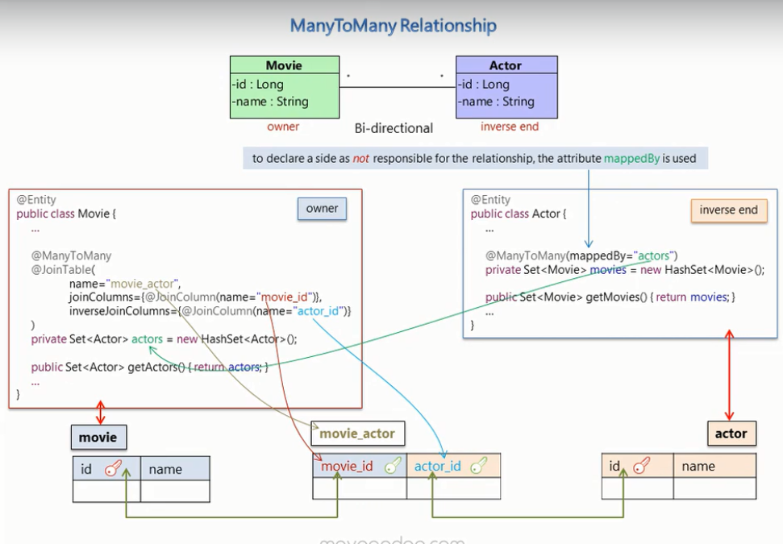

1. **Storing Collection of basic value type:**  we store it via separate table for the collection.

We use such syntax : @Collectionable(name=”TableName” @joinColumn(name=”xyz_id”)).

To avoid duplicate rows in collection table we usually have a composite primary key.

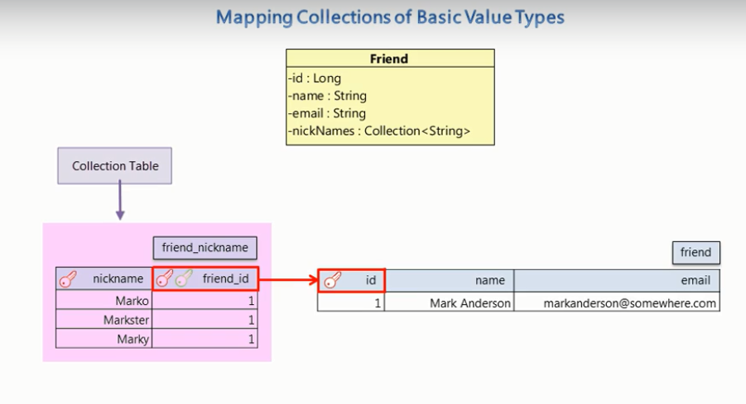

v

1. **Composite Primary Key:** A combination of more than 1 table columns that uniquely identifies a record. No matter how gud our selection is but it is not recommended to use random selected columns for composite primary key.
2. **Observe :**

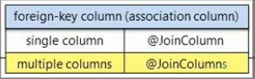

**Getting Started with JPA**